26th December 2018

**YOKOHAMA to Exhibit at Tokyo Auto Salon 2019**

YOKOHAMA announced on 21st December that it will participate in the Tokyo Auto Salon 2019 to be held 11th-13th January 2019. The YOKOHAMA exhibit will showcase the Company’s tyres and aluminium wheels.  
  
The tyre booth will introduce visitors to YOKOHAMA’s diverse line-up of tyres that appeal to car hobbyists. Accordingly, the booth will have a special focus on YOKOHAMA’s hobby tyres. The booth will also introduce YOKOHAMA’s high-level motor sports activities, which make important contributions to the Company’s development of technologies used in its consumer tyres.   
  
< Hobby tyres>  
The booth will include vehicles equipped with YOKOHAMA tyres representative of four tyre themes – sports, off-road, dress-up, and classic. Among these, the dress-up and classic theme tyres that will be displayed are scheduled to be put on the market in 2019. The booth also will display a future concept model of the ADVAN brand’s ultimate street sports tyre, the “ADVAN NEOVA”.

< Motor sports>  
The YOKOHAMA exhibit will include the SF19, the new model race car to be used from 2019 in the Japanese SUPER FORMULA Championship Series, Asia’s ultimate formula racing car series, and the YOKOHAMA-sponsored KONDO Racing team machine that will compete in the 2019 Nürburgring 24-hour endurance race. A number of live talk shows featuring drivers and managers of teams participating in races and rallies will also be held at the tyre booth.   
In addition to hobby tyres and motor sports, the booth also will display the “BluEarth-GT AE51”, a grand touring tyre to be marketed from February 2019 in Japan.  
  
The wheel booth will feature the “ADVAN Racing” brand line-up and introduce a number of new products to be unveiled in Japan for the first time. Forged models will include the “ADVAN Racing R6”, which was first unveiled at the SEMA Show in the United States in October 2018. Cast wheels will feature the “ADVAN Racing RSIII”, the new model of YOKOHAMA’s flagship model, the “ADVAN Racing RSII”. Both these new wheels will be attractively displayed on vehicles in the booth.  
  
YOKOHAMA has established its hobby tyre strategy as one of core elements of the broader consumer tyre strategy included in the Company’s three-year medium-term management plan, Grand Design 2020 (GD2020), implemented from 2018. In line with its hobby tyre strategy, the Company will accelerate the development of new products and expand the size line-up of existing products suitable for use with various types of hobby vehicles, from race cars to classic cars.

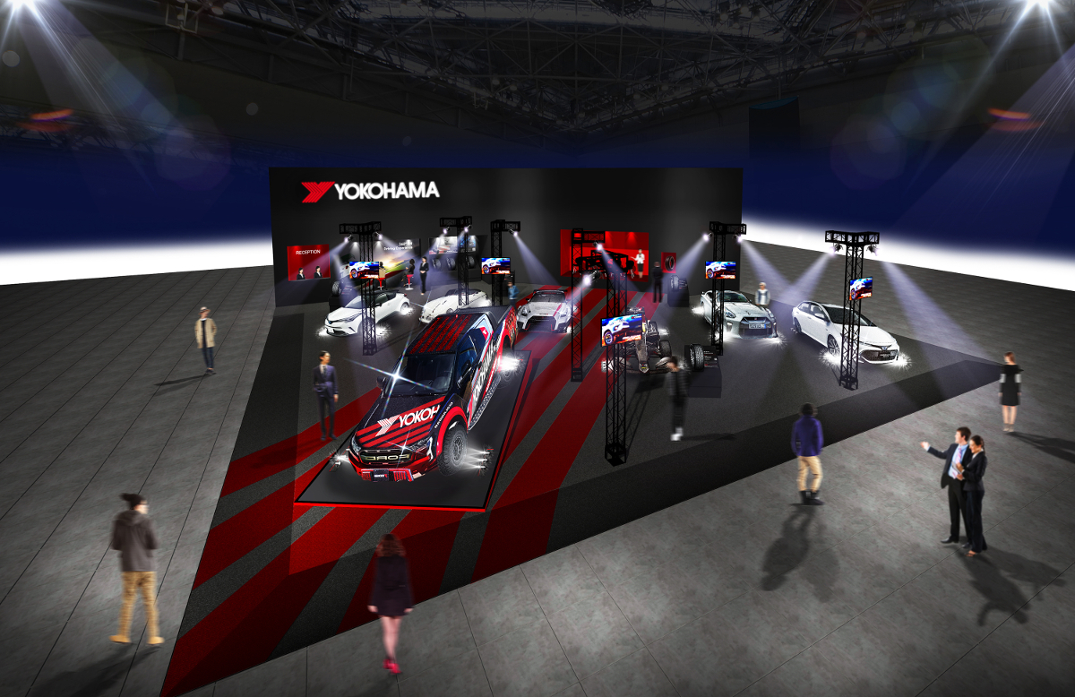

*Image of the YOKOHAMA tyre booth*

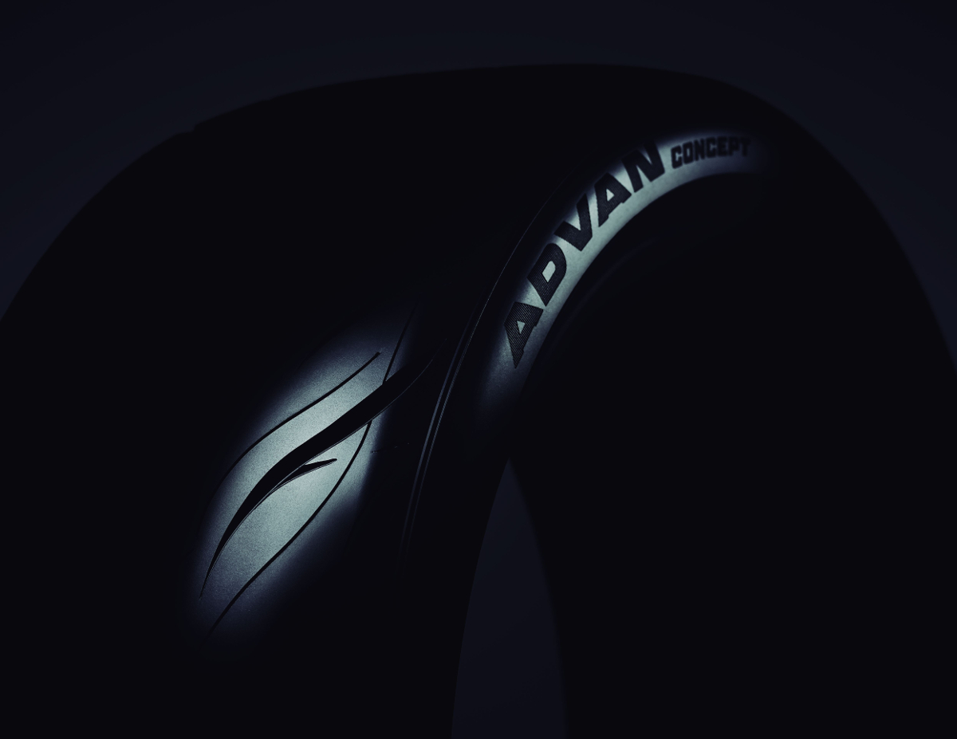

*Future concept model of “ADVAN NEOVA”*